**UNIFORM GUIDELINES**

**TOP:** Solid white, tan, or black shirt, long or short sleeves, dress or polo, no prints, patterns, or logos. Brown and navy blue are not acceptable. CHS-sponsored gear is acceptable (may not be altered)

**TOP Guidelines:**

1. Low-cut, too-tight, too-short shirts that reveal cleavage or midriff are unacceptable.
2. Jackets, blazers, sport coats, or sweaters worn for warmth must be uniform colors.

**ID Badges with Lanyard:** Must be worn at all times upon entering the building (If IDs or lanyards are lost there will be a $3.00 replacement fee).

**BOTTOM:**Solid black, tan/khaki pants/slacks or skirts. Brown and navy blue are not acceptable. CHS-sponsored gear is acceptable.

**BOTTOM Guidelines:**

1. Spandex or other elasticized pants that fit too tightly against the body are not acceptable
2. Pants/slacks must be worn at the waist – **\*NO SAGGING\***
3. Short pants/slacks or skirts must be no more than two inches above the knee all the way around – not just in the front. Shorter skirts are not allowed even with tights, jeggings, or leggings.

**SHOES/SOCKS:** Students may wear any color shoes.

**SHOES/SOCKS Guidelines:**

1. Shoes must cover toes
2. Thongs, sandals, slides, house shoes, etc. are not acceptable.
3. No derogatory pictures
4. Crocs are acceptable.

**ACCESSORIES:** (Belts, jewelry, headbands, hair bows, ribbons, neckties, fashion scarves):

**ACCESSORIES Guidelines:**

1. Belts and jewelry with suggestive words and derogatory or profane words are not acceptable
2. Fishnet hosiery is not permissible during the school day
3. Unless worn for religious, cultural, or medical reasons, scarves, bonnets, doo rags, wave caps, bed scarves/slumber caps, or other head coverings are not allowed in the building. *NOTE: It is highly recommended that belts be worn to prevent SAGGING pants.

**Dress for Your Future GUIDELINES:**

Occasionally for Young Emerging Leaders students will be encouraged to dress professionally to highlight professional dress expectations. This will always be free of charge in an effort to promote a professional culture.

**FIELD TRIP GUIDELINES:**

When students are scheduled for an out-of-school field experience during the day, they are expected to follow the Carnahan uniform policy unless otherwise stated by the field trip sponsors. If students are not wearing uniforms, they are to be professionally and neatly dressed. Please do not wear:

(1) Hooded tops that are not being worn as a coat/outerwear.

(2) Clothing with holes that reveal bare skin that normally should be covered – such as cleavage, shoulders, midriffs, and thighs.

(3) Short, tight, low-cut (front and back), off-the-shoulder, or see-through clothing.

(4) Jeans of any kind or color.

(5) Sweatpants/fleece pants/jogging pants/pajama pants jeggings, leggings, or loungewear.

(6) Head scarves, bonnets, bed scarves, slumber caps.

**SUGGESTED UNIFORM SHOPPING LIST:**

* 1-2 white, short-sleeved polo type shirts, without logos
* 1-2 black, short-sleeved polo-type shirts, without logos
* 1-2 tan, short-sleeved polo-type shirts, without logos
* 1-2 white, tan or black long-sleeved polo-type shirts
* 1-2 pair long khaki or tan slacks (not jeans, not spandex)
* 1-2 pair long black slacks (not jeans, not spandex)
* 1-2 pair black and/or tan knee-length shorts and/or capris
* Black and/or tan jacket or sweater
* Belt(s)

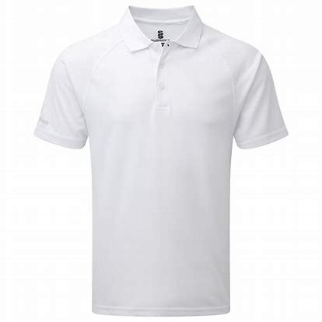

**DRESS DOWN GUIDELINES:**

On occasion, students are allowed to have a dress down day. There may be a small cost associated or they may be free. They will be used as an incentive for meeting school-wide goals or as a school fundraiser as need arises. On those days, regular attire is permitted. However, the following are **not acceptable;**

* Clothing that reveals bare skin – (midsection and upper thigs)
* Low-cut (without undershirt) or see-through shirts (front or back).
* Pajama pants, lounge wear, robes, house shoes, etc.
* Skirts that do not pass fingertip-test.
* Off-the-shoulder tops.
* Unacceptable shoes; sandals, slides, flip flops, house shoes.
* All mesh and shear
* Sagging.
* Head scarves, bonnets, bed scarves, wave caps, du-rags, etc. (issues with religious practices should be presented to administration)